Reg No : 192211264

Name: R.Malathy

DAY 02 – FUNDAMENTALS OF COMPUTING

17.

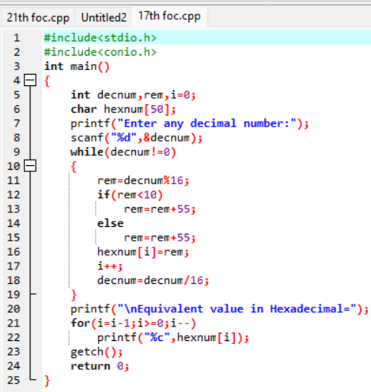

OUTPUT:

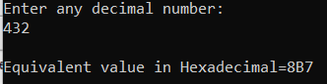

21.

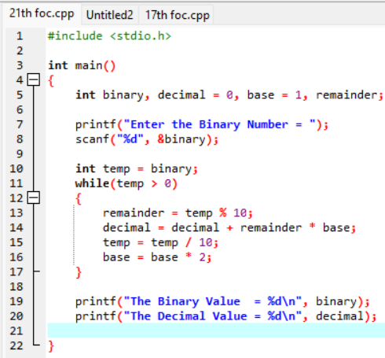

OUTPUT:

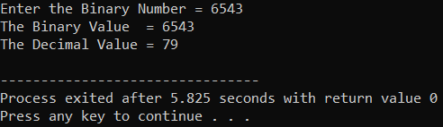

19.

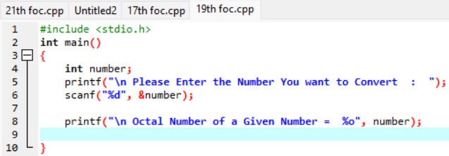

OUTPUT:

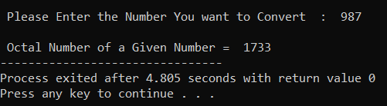

20.

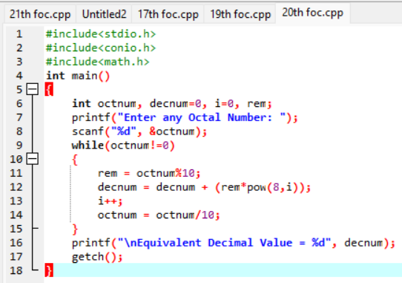

OUTPUT:

